

Challenge the Champions! | Side Event
World Pool Masters 2007

Event | Challenge the Champions!  Side Event World Pool Masters 2007
Date | Thursday June 7th 2007
Start & End | Start 1.30 pm & finished 10.00 pm
Venue | Club 8  Admiraal de Ruijterweg 56B  1056 GL Amsterdam  The Netherlands  Tel: +31- (0)20 685 1703
Format | - 9ball, winner breaks up to final  - Poole system till last 16, best of 7  - Single knock out from last 16, best of 13
Time table | 1.30 pm Start tournament  5.30 pm Start knock out faze  6.30 pm Quarter final  7.30 pm Semi final  8.30 pm Final  10.00 pm Ceremony
Maximum number of player | 48 players, 16 World Pool Masters players and 32 players thru international qualification rounds.
Seated players | Nick van den Berg Holland (confirmed)  Niels Feijen Holland (confirmed)  Jasmin Ouschan Austria (pending)  Ralf Souquet Germany (pending)  David Alcaide Spain (pending)  Ronnie Alcano Philippines (confirmed)  Tony Drago Malta (confirmed)  Tyler Edey Canada (confirmed)  Thomas Engert Germany (pending)  Pat Holtz Scotland (confirmed)  Li He-Wen China (confirmed)  Imran Majid England (confirmed)  Naoyuki Oi Japan (confirmed)  Oliver Ortmann Germany (pending)  Fabio Petroni Italy (confirmed)  Wu Chia-Ching Taiwan (confirmed)
Price money*  *Below 28 paying players the price money will be lowered accordingly. | 1e 1.000 euro  2e 750 euro  3e/4 400 euro  5e-8e 200 euro  9e-16e 100 euro  17e-48e passé par tout World Pool Masters (value 44 euro).
Buffet | Every player in Challenge the Champions will be offered a tasty buffet.
Entry fee (payment in advance) | 150 euro a person
Contact | Royal Dutch Pool Billiards Association (KNBB)  Anton Rebisz  Phone + 31 6 422 11 256  Mail a.rebisz@chello.nl

“Challenge the Champions!” is made possible by:
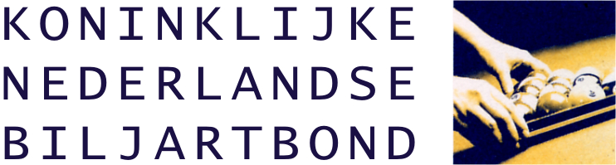
Partypoker.com World Pool Masters, Matchroom Sport, Club 8, Royal Dutch Pool Federation and Rebisz Public Relations.

